BGP Policy Lab - Subnet Leaking
BGP Deployment Workshop

Introduction
This lab continues the series demonstrating how an AS can use Local Preference to control outbound routing paths, and how to use MEDs (multi-exit discriminators or metrics), BGP communities, AS path prepends, and subnet leaking to determine inbound routing paths. All five are very powerful tools for ISPs to control how their external peering links are used.
Refer to the BGP presentations and documentation for more information about the BGP path selection process and the default values for, and priorities of, the “local_pref” and “metric” attributes.

Lab Topology
The following common topology is used for this lab.
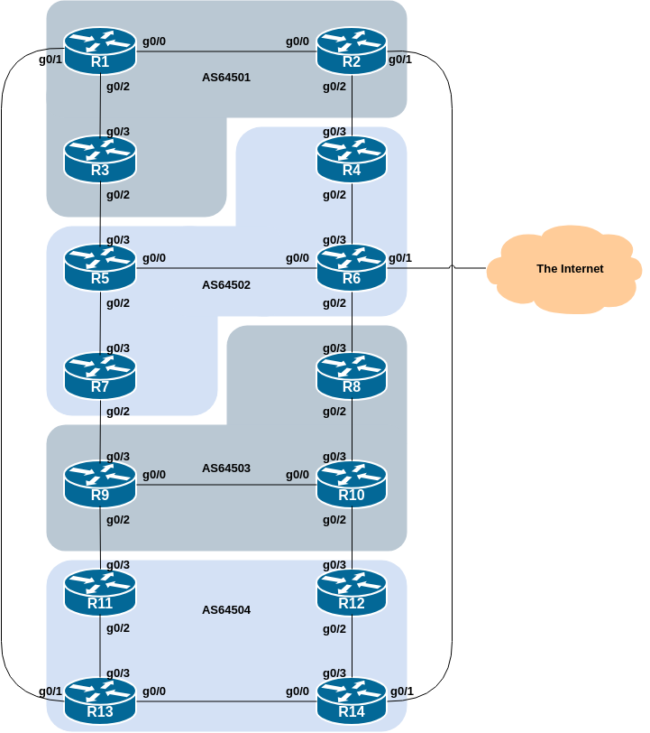

Background
As a reminder, the diagram below displays the desired traffic flows between particular routers and ASes. Eight traffic flows are to be implemented.
The arrows in the diagram show the flows that will be configured. Each arrow originates from a border router in an AS, and terminates on one of the routers in another AS. This signifies the traffic flows desired for the links between the two routers.
Each of the policy labs we are going to do has a description on how to implement the traffic flow represented by each arrow. It is important to pause and think what the policy is, and what needs to be done to achieve it.
If at any time there is any doubt as to the configuration required, ask the lab instructors.
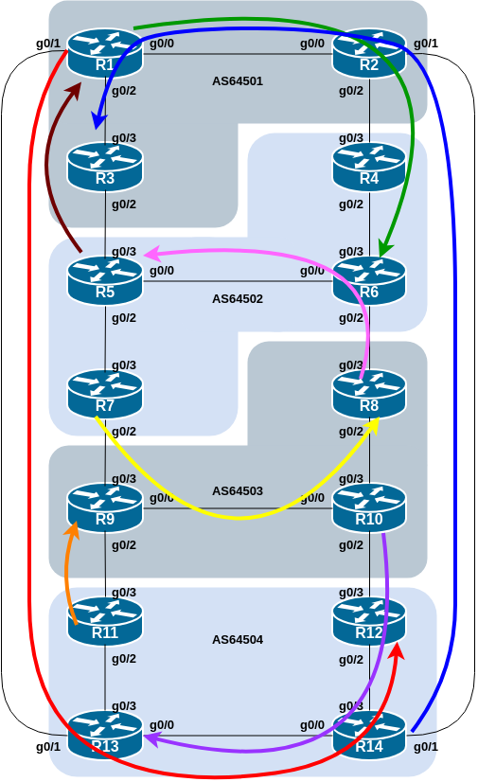
The diagram may look “busy” but the key to success is to focus on the traffic engineering that your group needs to do, and “ignore” the other activities by other groups.

Addressing
As a reminder, the addressing used for this lab is documented in the address plan and is replicated here for convenience:
AS Number | Router | IPv4 subnet | IPv6 subnet
AS64501 | Router1 | 100.68.1.32/28 | 2001:DB8:1:100::/56
 | Router2 | 100.68.1.48/28 | 2001:DB8:1:200::/56
 | Router3 | 100.68.1.64/28 | 2001:DB8:1:300::/56
AS64502 | Router4 | 100.68.2.32/28 | 2001:DB8:2:100::/56
 | Router5 | 100.68.2.48/28 | 2001:DB8:2:200::/56
 | Router6 | 100.68.2.64/28 | 2001:DB8:2:300::/56
 | Router7 | 100.68.2.80/28 | 2001:DB8:2:400::/56
AS64503 | Router8 | 100.68.3.32/28 | 2001:DB8:3:100::/56
 | Router9 | 100.68.3.48/28 | 2001:DB8:3:200::/56
 | Router10 | 100.68.3.64/28 | 2001:DB8:3:300::/56
AS64504 | Router11 | 100.68.4.32/28 | 2001:DB8:4:100::/56
 | Router12 | 100.68.4.48/28 | 2001:DB8:4:200::/56
 | Router13 | 100.68.4.64/28 | 2001:DB8:4:300::/56
 | Router14 | 100.68.4.80/28 | 2001:DB8:4:400::56

Clean up
Before we start with this scenario it is important that the configuration from the previous BGP Community lab is removed.
This involves removing the route-maps, prefix-lists and the per-neighbour configuration used for the AS_PATH prepends.
All router teams should do this, and then do a route-refresh of their EBGP peerings.

Subnet Leaking
This lab in the BGP Policy series introduces the final of the four methods of influencing inbound policies, Subnet Leaking.
The problem with AS_PATH prepend is that the EBGP neighbour can simply override the prepend initiated by their EBGP peer by applying a local-preference to the path learned. We can prepend all we want, but the local-preference set by a neighbour will always take priority.

Preparation
Here Subnet Leaking is used to demonstrate how to influence inbound traffic flows. Like the AS_PATH prepend, leaking of subnets is visible across all autonomous systems, not just between immediate neighbours as was the case for MED and the BGP Community.
As for the previous scenario, please read the instructions carefully, and discuss within your team, and in your AS, how you are going to implement the following.
What we are going to do is take the IPv4 /28 and IPv6 /56 which is being originated by each router team, and subnet them. We will announce the first /29 out of the /28, and the first /60 out of the /56 (IPv6 subnetting is done on nibble boundaries).
Each router team should now add this configuration to their router. Here is an example for Router5:
ip route 100.68.2.48 255.255.248 Null0
ipv6 route 2001:DB8:2:200::/60 Null0
!
router bgp 64502
address-family ipv4
network 100.68.2.48 mask 255.255.255.248
!
address-family ipv6
network 2001:DB8:2:200::/60
!
Use this example to construct a configuration for your own router. Once done, check that you see the IPv4 /29 and IPv6 /60 in the BGP table.

Policy Implementation
The example in this step achieves exactly the same traffic flow between neighbouring ASes as in the previous scenario for the networks in question. Refer to the diagram above for a picture of the traffic flow…

AS 64501:
- All traffic TO 100.68.1.64/29 and 2001:DB8:1:300::/60 (Router3) from anywhere in the lab topology must enter AS 64501 via the Router14 – Router2 link. (Hint: this means that Router2 must announce 100.68.1.64/29 and 2001:DB8:1:300::/60 to Router14 only (and not to Router4). Router1 and Router3 must not leak the /29 and /60 to their EBGP peers.)
- All traffic TO 100.68.1.32/29 and 2001:DB8:1:100::/60 (Router1) from anywhere in the lab topology must enter AS 64501 via the Router5 – Router3 link. (Hint: this means that Router3 must announce 100.68.1.32/29 and 2001:DB8:1:100::/60 to Router5. Router1 and Router2 must not leak the /29 and /60 to their EBGP peers.)

AS 64502:
- All traffic TO 100.68.2.48/29 and 2001:DB8:2:200::/60 (Router5) from anywhere in the lab topology must enter AS 64502 via the Router8 – Router6 link. (Hint: this means that Router6 must announce 100.68.2.48/29 and 2001:DB8:2:200::/60 to Router8. Router4, Router5 and Router7 must not leak the /29 and /60 to their EBGP peers.)
- All traffic TO 100.68.2.64/29 and 2001:DB8:2:300::/60 (Router6) from anywhere in the lab topology must enter AS 64502 via the Router2 – Router4 link. (Hint: this means that Router4 must announce 100.68.2.64/29 and 2001:DB8:2:300::/60 to Router2. Router5, Router6 and Router7 must not leak the /29 and /60 to their EBGP peers.)

AS 64503:
- All traffic TO 100.68.3.32/29 and 2001:DB8:3:100::/60 (Router8) from anywhere in the lab topology must enter AS 64503 via the Router7 – Router9 link. (Hint: this means that Router9 must announce 100.68.3.32/29 and 2001:DB8:3:100::/60 to Router7 only (and not to Router11). Router8 and Router10 must not leak the /29 and /60 to their EBGP peers.)
- All traffic TO 100.68.3.48/29 and 2001:DB8:3:200::/60 (Router9) from anywhere in the lab topology must enter AS 64503 via the Router11 – Router9 link. (Hint: this means that Router9 must announce 100.68.3.48/29 and 2001:DB8:3:200::/60 to Router11 (and not to Router7). Router8 and Router10 must not leak the /29 and /60 to their EBGP peers.)

AS 64504:
- All traffic TO 100.68.4.48/29 and 2001:DB8:4:200::/60 (Router12) from anywhere in the lab topology must enter AS 64504 via the Router1 – Router13 link. (Hint: this means that Router13 must announce 100.68.4.48/29 and 2001:DB8:4:200::/60 to Router1. Router11, Router12 and Router14 must not leak the /29 and /60 to their EBGP peers.)
- All traffic TO 100.68.4.64/29 and 2001:DB8:4:300::/60 (Router13) from anywhere in the lab topology must enter AS 64504 via the Router10 – Router12 link. (Hint: this means that Router12 must announce 100.68.4.64/29 and 2001:DB8:4:300::/60 to Router10. Router11, Router13 and Router14 must not leak the /29 and /60 to their EBGP peers.)

The traffic flow we want to achieve above is also visually described in the earlier lab diagram, where the coloured arrows show the traffic flow we want to achieve between ASes.

Example Configurations
Here is a sample configuration for Router2 in its peerings with Router4 and Router14 for the AS 64501 example above:
ip prefix-list R4-v4out deny 100.68.1.32/29
ip prefix-list R4-v4out deny 100.68.1.64/29
ip prefix-list R4-v4out permit 0.0.0.0/0 le 32
!
ip prefix-list R14-v4out deny 100.68.1.32/29
ip prefix-list R14-v4out permit 0.0.0.0/0 le 32
!
ipv6 prefix-list R4-v6out deny 2001:DB8:1:100::/60
ipv6 prefix-list R4-v6out deny 2001:DB8:1:300::/60
ipv6 prefix-list R4-v6out permit ::/0 le 128
!
ipv6 prefix-list R14-v6out deny 2001:DB8:1:100::/60
ipv6 prefix-list R14-v6out permit ::/0 le 128
!
router bgp 64501
address-family ipv4
neighbor 100.68.1.5 remote-as 64502
neighbor 100.68.1.5 description EBGP peering with Router4
neighbor 100.68.1.5 prefix-list R4-v4out out
neighbor 100.68.4.8 remote-as 64504
neighbor 100.68.4.8 description EBGP peering with Router14
neighbor 100.68.4.8 prefix-list R14-v4out out
!
address-family ipv6
neighbor 2001:DB8:1:3::1 remote-as 64502
neighbor 2001:DB8:1:3::1 description EBGP peering with Router4
neighbor 2001:DB8:1:3::1 prefix-list R4-v6out out
neighbor 2001:DB8:4:5:: remote-as 64504
neighbor 2001:DB8:4:5:: description EBGP peering with Router14
neighbor 2001:DB8:4:5:: prefix-list R14-v6out out
!
Notice again the use of descriptive names for the prefix-lists.
Also notice the logic being used here… We only want the /29 and /60 to be leaked on specific peerings, so there we have a global allow in the prefix-list. For peerings where we do not want the /29 and /60 being leaked, we put in a specific deny for the /29 and /60.
Comment: In day-to-day Internet operations, all EBGP peerings will have prefix-filtering on them (as per the Mutually Agreed Norms for Routing Security principles). So what would normally be done is that prefix filters would have specific permits for what is allowed out in a peering, with a blanket deny for everything else.

Implementation
Use the above example to come up with a configuration for your router and the policy it needs to implement on its EBGP session. Discuss with the other members of your group (your AS) - it is likely that you will have some common configuration snippets you can share with each other.
Note: Router2 and Router9 have two EBGP peers, and will need a separate prefix-list for each peering. Use the hint above, naming the prefix-list after the peer name (and is also common practice in day to day network operations).

Verification
Once the policy has been implemented, remember to run a route-refresh on the EBGP session. And then try doing a traceroute (trace command, and remember to specify the source interface – why?) through the network, to the destination you have targeted. Does the traceroute follow the arrows in the diagram? If not, why not? Maybe check the BGP table and if your colleagues in your AS have completed their steps in the exercise as well.
On completion of the exercise the instructor will display traceroutes to the selected destinations on the classroom screen - the traffic has to enter the AS as specified in the exercise above and the instructor will check from various points of the lab that the traffic is flowing as intended.

Summary
This series of BGP Policy labs has demonstrated several ways of influencing inbound and outbound routing policy.

Question: What is the difference in the resulting traffic flow patterns between using MED, BGP Communities, AS_PATH prepend, and Subnet Leaking?

Answer: AS PATH prepend and Subnet Leaking affects routing announcements between two ASes, and is visible everywhere, even outside the two ASes which are making use of the prepend information. MEDs only apply between multiple peerings between the same AS. If the peer AS is announcing the local AS onwards, the metric set is that of the peer AS, not the local AS. Communities are generally only used in peerings between neighbouring ASNs.

Question: What advantage do you see that Subnet Leaking has over using AS_PATH prepend?

Answer: AS_PATH prepends can be overridden by Local Preference in another AS. Leaking a subnet is globally visible and takes priority over the path for its covering subnet. The only way another AS can override the leaked subnet is to block it in its incoming prefix filters.

Question: what are the potential problems with Subnet Leaking?

Answer: the instructors will have already covered the BGP Best Practices presentation. In there, the serious problem of deaggregation and the impact it has on the global routing table will have been discussed. Leaking subnets for traffic engineering purposes needs to be considered and only used when there is no other method available, because every single AS in the Internet that is carrying the full BGP table will likely see that leaked subnet - and if every AS globally did this, the Internet routing table could end up being unmanageable.

Consult the BGP documentation for more information. There are many possible variations on the examples given in this module. Remember the following points:
- local preference is used for influencing policy within an AS
- MEDs are used to influence policy over multiple links between the local and an immediately neighbouring AS
- BGP Communities can also be used to influence policy over multiple links between the local and neighbouring AS
- The AS path prepend is used to influence external policy on a global scale (which includes the immediately neighbouring AS).
- Subnet Leaking is used to influence external policy on a global scale (which includes the immediately neighbouring AS).

Review Questions
- Which is the most effective way of influencing how traffic leaves your network?
- How useful do you think MEDs are in the real live Internet? Consider the answer to question 1 before replying!

